Group Project 4: Finalization

CST 8288 OOP with Design Patterns

Environmental Compliance Monitoring System (ECMS)

Group Members:

Hoorulain Ahmad

Raymond Lu

Ahmed Boudouh

Academic Report

Contributors:
- Ahmed Boudouh: Responsible for creating a WAR file for Tomcat 9, including source code, static resources, and dependencies. Ensured password validation and security.
- Added the Navigation menu, Signup, Login and password reset forms. Incorporated Design and Singleton patterns as well as factory and builder patterns. Implemented the use of Pattern using servlets, DAO Pattern with JDBC (UserDAO), multi-threading for email sending (using thread).
- Raymond Lu: Worked on the Database Description Language (DDL) file and implemented CRUD operations. Added some extra code and tweaked some code.
- Hoorulain Ahmad: Delivered a video demonstration along with the voiceover and a detailed project report.

Accomplishments:
In the development and refining of the web application, each team member contributed significantly to the completion of key tasks. The accomplishments include:
- WAR File Creation: Ahmed Boudouh successfully created a WAR (Web Application Archive) file for Tomcat 9, which encapsulated the source code, static resources, and all necessary dependencies. This WAR file is essential for deploying the web application onto a server, ensuring it runs efficiently and reliably. Ahmed ensured password validation and security. He also added the navigation menu, Signup, Login and password reset forms.
- Database Definition and CRUD Implementation: Raymond Lu worked on the Database Description Language (DDL) file, which played a crucial role in defining the database structure for the application. In instances where the application required automatic database generation, Raymond implemented the necessary code. Furthermore, Raymond was responsible for adding Create, Read, Update, and Delete (CRUD) operations to the user profile, ensuring that users could interact with the application data seamlessly.
- Video Demonstration and Project Report: Hoorulain Ahmad created an informative video demonstration of the application in action, showcasing its functionality on at least two browsers, including Chrome. This video, lasting between 1-3 minutes, provided a concise visual guide for stakeholders. Hoorulain also explained the screen recording via voice over. Additionally, Hoorulain contributed a detailed project report, including a comprehensive overview of the team’s accomplishments, the challenges faced, and the course concepts applied throughout the project.
- Password Validation and Security:
Worked to ensure that passwords were validated against strict rules: at least 8 characters, one uppercase letter, one lowercase letter, and one number, among other requirements. This was crucial in preventing weak passwords from being used. Furthermore, all passwords are stored as hashed values using BCrypt, an advanced hashing algorithm, to protect users' data and enhance the overall security of the application.
- Design Patterns Implementation:
The application incorporated several design patterns to make the code more efficient and scalable:
- Singleton Pattern: This was used to manage a single database connection, which saved system resources and ensured that only one instance of the database connection was active at any given time.
- Factory Pattern: The factory design pattern was implemented to centralize the creation of user objects, making it easier to manage and create users with consistent data and properties.
- Builder Pattern: The builder pattern was used to create complex user objects, especially when additional attributes such as roles or permissions needed to be added. This allowed for flexibility and modularity in user creation

Running the webpage:
Prior to running the webpage, it is important to change the database password in the UserDAO.java. Below is the screenshot where the database password needs to be changed according to the user’s server.

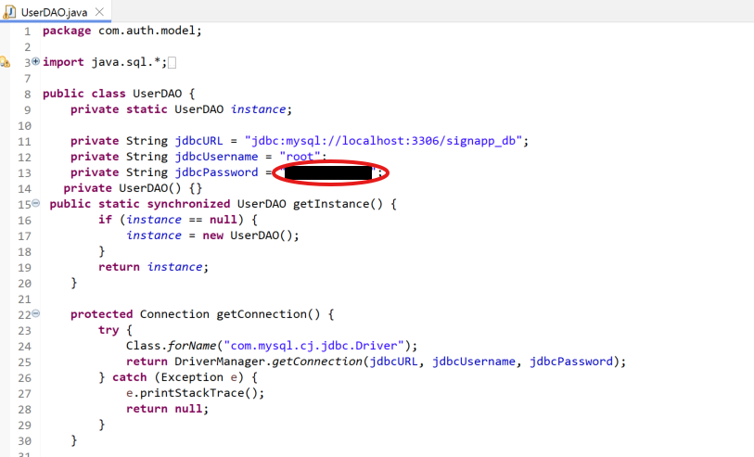

Challenges and Solutions:
Throughout the development process, the team faced several challenges, but we were able to address them effectively:
- Challenge: Compatibility Issues with Different Browsers
During the video demonstration, it was noted that the application’s behavior varied slightly across different browsers. This discrepancy led to concerns about the application’s cross-browser compatibility.
Solution:
To overcome this challenge, the team tested the application on multiple browsers, including Chrome, Firefox, and Edge. This ensured that any issues related to compatibility were identified and rectified before finalizing the video demonstration. Additionally, the team adjusted the front-end code to ensure better cross-browser consistency.

- Challenge: Integrating Email Verification and Password Recovery
Implementing features like email verification and password recovery required integration with third-party services (for sending emails) and ensuring the security of the process. Ensuring the proper handling of tokens for password reset posed some challenges.
Solution:
The team implemented email services to handle the sending of activation links and password recovery tokens securely. We also ensured that proper security measures were in place, such as token expiration and one-time use, to prevent misuse. This approach provided both functionality and a secure user experience.

- Challenge: Password Validation and Security Implementation
Establishing strict password validation and secure password storage, such as the use of BCrypt hashing, was crucial for user data security. Ensuring this was done without affecting the user experience was a challenge.
Solution:
The team incorporated password validation rules that were clear to the user and provided real-time feedback during registration. For storing passwords, BCrypt was used, which ensured that even if the database were compromised, the actual user passwords would remain secure due to their hashed and salted nature.

- Challenge: Managing Complex User Objects
As the project involved user roles and permissions, designing a flexible system that could accommodate different configurations of user data was necessary.
Solution:
By using the Builder Pattern, the team ensured that complex user objects could be constructed in a clean and maintainable way. This made adding features like roles or permissions straightforward without complicating the core user creation process.

- Challenge: Video Production with Limited Timeframe
Hoorulain had a time constraint for producing the video demonstration. Given that the video had to showcase the application on multiple browsers, the pressure of recording, editing, and finalizing the video within a short period posed a challenge.
Solution:
Hoorulain used the Snipping tool and Canva to record the screen in an efficient manner. With a clear plan for the demonstration and by focusing on the core functionality, the video was completed within the required time. The absence of a voice-over also made it easier to complete the video quickly while still ensuring it was informative and clear.

Course Concepts Applied:
The project allowed the team to apply several key concepts learned throughout the course. These include:
- Web Application Deployment and Configuration (WAR File for Tomcat 9):
Ahmed applied the concept of web application packaging and deployment using Tomcat, which involved creating a WAR file. This reinforced knowledge of deploying applications on web servers, ensuring that both the source code and necessary resources were bundled together for smooth operation.
- Controller Pattern using Servlets:
In this project, the web application uses a common structure called the Controller Pattern, which helps manage how users interact with the site. Servlets like SignupServlet, SigninServlet and ResetPasswordServlet play the role of controllers. These are essentially Java classes that listen for user actions- like when someone fills out a form to register or log in- and handle what happens next. For example, when a user signs up, the signup servlet grabs the input data (username, e-mail and password), checks if it's valid and then sends it off to the next layer that handles the actual logic behind the scenes. Depending on what happens- like if the sign up is successful or if something is wrong- the servlet will forward the user to the right page like a profile page or an error screen. This approach helps keep the logic clean and organized by separating the user interface, business logic and databases access.
- DAO pattern with JDBC (UserDAO):
The app uses the DAO (Data Access Object) pattern to talk to the database in a clean structured way. Instead of mixing database code all over the place, everything related to database operations is handled by the UserDAO class. This class has methods for things like adding a new user, checking if a user already exists, verifying passwords, and updating password records. What's nice about this pattern is that it keeps the database logic separate from the rest of the application. The DAO uses JDBC (Java as database connectivity tool) to connect to MySQL database and execute SQL queries. It also uses prepared statement to help protect against SQL injection attacks. Plus, the DAO is set up as a Singleton, meaning there is only 1 shared instance used across the app- this helps manage resource is an avoid issues when multiple users are accessing the system at the same time
- Multi-threading for email sending:
The app also includes functionality for sending emails, like during signup or password reset processes. It uses tools like Javamail and Sendgrid to handle that. While the code snippets don't directly show threads being created, the fact that these libraries are included strongly suggests that e-mail sending happens in the background. In typical Java web apps, sending emails in the background [instead of waiting for it to finish before moving on] is done using threads or executor services. This makes sure the user isn't stuck waiting while an e-mail is being sent. So even if we don't see explicit threading code, it's likely happening through those e-mail libraries, helping the app remain smooth and responsive
- Database Design and CRUD Operations:
Behind the scenes, the app connects to a MySQL database where it stores user information- like usernames, emails, and securely hashed passwords. The design follows a clear structure of her handling basic operations known as CRUD: Create, Read, Update and Delete. Raymond utilized concepts related to relational database management systems (RDBMS) and structured query language (SQL) to define the database schema and implement CRUD operations. The application of these concepts helped the team understand the importance of database interactions and data manipulation within a web application.
- Security Practices (Password Validation and BCrypt Hashing):
The team implemented advanced security measures, including password validation, token-based recovery, and BCrypt hashing, which were aligned with industry best practices in securing user data.
- Design Patterns:
The use of design patterns, such as Singleton, Factory, and Builder, demonstrated a deeper understanding of software architecture. These patterns allowed the team to create a scalable, maintainable, and flexible codebase, adhering to solid object-oriented principles.
- Cross-Browser Compatibility and User Experience Testing:
Hoorulain applied principles of user experience (UX) design and cross-browser compatibility during the video demonstration. Testing the application on multiple browsers demonstrated the importance of ensuring the application works seamlessly across diverse platforms to provide a consistent user experience.
- Project Documentation and Communication:
Throughout the project, the team emphasized clear communication through project reports and video demonstrations. The documentation process, including the creation of detailed reports, reinforced the importance of sharing knowledge and progress in an understandable format.

Conclusion:
In conclusion, the development of this web application was a successful and enriching experience, allowing the team to apply a wide variety of technical skills and concepts. This web application is built using smart architectural choices. From creating the WAR file and implementing complex database features to adding essential security measures like email verification, password recovery, and BCrypt hashing, each contributor played a vital role in delivering a secure and functional application. The challenges encountered, including browser compatibility and integrating security features, were effectively solved through teamwork and the application of best practices.
This project not only enhanced our understanding of web application development but also reinforced the importance of security, user experience, and maintainable code. The use of design patterns and the integration of key concepts from the course helped us create an efficient and scalable solution. The app connects to a MySQL database and performs all the essential tasks- signing up, logging in, resetting passwords - using secure, well-structured code. This project has equipped the team with valuable skills and insights that will be beneficial in future development endeavors. Everything works together to create a system that's sufficient easy to maintain and secure for users.

Project Report Prepared By:
Hoorulain Ahmad

References

Baeldung. (n.d.). Java email with SendGrid. Baeldung. Retrieved March 28, 2025, from Sending Emails in Spring Boot Using SendGrid | Baeldung

DZone. (2020, February 25). Hashing passwords in Java with BCrypt. DZone. Retrieved March 28, 2025, from https://dzone.com/articles/hashing-passwords-in-java-with-bcrypt

Dev.to. (2019, July 3). Login system with JWT token and email reset password using regular expressions in Java. Dev.to. Retrieved March 28, 2025, from https://dev.to/mspilari/login-system-with-jwt-token-and-email-reset-password-571

GeeksforGeeks. (n.d.). *Validating a password using regular expressions in Java*. GeeksforGeeks. Retrieved March 28, 2025, from https://www.geeksforgeeks.org/how-to-validate-a-password-using-regular-expressions-in-java/

